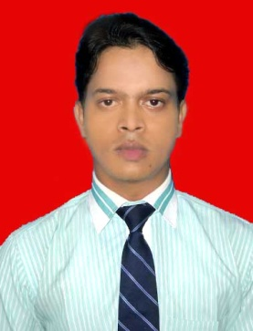

**CURRICULAM VITAE**

|  |  |
| --- | --- |
| **OF**  **AMIYA KUMAR MAHATO** |  |

OBJECTIVE:

Seeking a position in an industry where I can utilize my skills and abilities and achieve

professional growth while being resourceful,innovative and flexible,showing my internal

smartness.

________________________________________________________

**Specialization**: Marketing(Major) and Finance(Minor)

___________________________________________________________________

**PROFESSIONAL QUALIFICATION**:

Pursued MBA, (2009-11) from DSMS Business School, Durgapur, Affiliated by West Bengal

University of Technology, Approved by A.I.C.T.E., New Delhi. Final Exam is in April,2011

Knowledge of M/S Office and ..Tally

**_______________________________________________________________**

**EXPERIENCE:**

Worked as C.R.O for Airtel for 5 months.

Presently working in Sarvodaya Hospital (1year & 5 months) as a MARKETING EXECUTIVE.

_________________________________________________________

**EDUCATIONAL QUALIFICATION**

B.Com(HONS) - Burdwan Raj College, The University of Burdwan( 2005-2008)

I.S.C - ST.Michael’s School, Durgapur (2003-2005)

I.C.S.E -ST.Michae’s School, Durgapur (2002-2003)

__________________________________________________________

**SUMMER INTERNSHIP:**

Done my summer internship from OUTLOOK GROUP(Kolkata),on DIRECT- MARKETING.

______________________________________________________________

**STRENGTHS :**

* Hard working.
* Self-confident.
* Love to work as a team.

_____________________________________________________________

**ACHIEVMENTS:**

* Awarded trophy for man of the match in a cricket tournamaent sponsored

by Phillips Carbon Black Limited.

* Was certified for being the runner up in a Zonal competition held in N.S.H.M Business School(Durgapur)

_____________________________________________________________

**LINGUISTIC PROFICIENCY**: English, Hindi, and Bengali

**___________________________________________________________________**

**HOBBY:**

* Listening misic
* Time-Management
* Self-Scanning

__________________________________________________________

**PERSONAL DETAIL**

Name : AMIYA KUMAR MAHATO

Father : ASHOKE KUMAR MAHATO

Date of birth : 01/12/1985

Nationality : Indian.

Religion : Hindu.

Gender : Male.

Marital status : Single.

Email ID : mahato**.**amiya@yahoo.com

: amiya.m@sarvodayahospital.com

Cell no : +91-7838858552

: +91-9560646856

**REFERENCE:**

**NAME** : Dr. D.P. Samanta

**DESIGNATION** : Principal

**ORGANIZATION** : DSMS Business School, Durgapur

**Contact No.** : +91-9434334934

_________________________________________________________

**DECLARATION:**

I hereby declare that all the statements stated above are absolutely true to the best of my knowledge.

Date:

Place: **DURGAPUR**

Amiya kumar mahato